An integer is any negative or positive whole numbe
It is denoted by letter Z
Z= ...-8,-7,-6,-5,-4,-3,-2,-1 0 ,1,2,3,4,5,6,7,8....

NUMBER LINE

INTEGERS ON NUMBER LINE
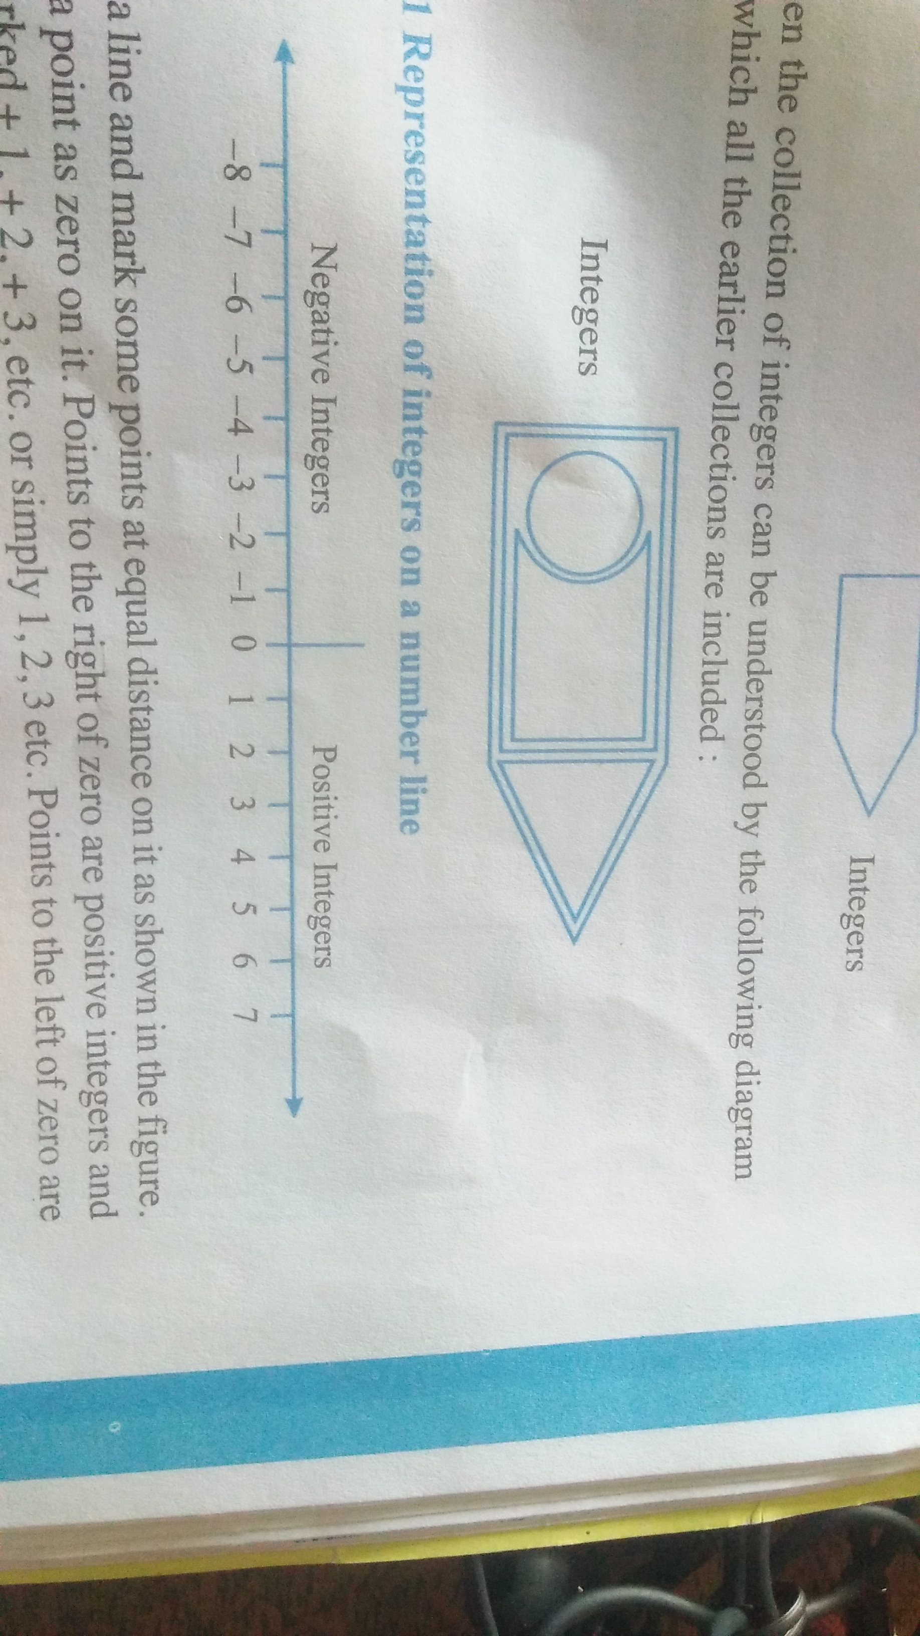
on the number line for positive integers we move to the right from zero and for negative integers move to the left from zero.

I Represent on a number line:-
a) +6 c)+8
b)-6 d)-5
II Comparing numbers:-
1) 100__200
2) 8 ___-3
3)-45 ___+70
4) -60 ___-50
5) -5___-9
III Write the following in ascending and descending order
Example: -9 , 3, -6 , 8 , -1 , 10
A.o =-9 ,-6,-1,3,8,10
D.o = 10,8,3,-1,-6,-9
1) -8,5,-4,2,0,6
2) 3,-4,0,-9,4,1
ADDITION AND SUBTRACTION OF INTEGERS

+ x + = + | -- x - = +
+ x - = - | - x + = -

* you add when you have two positive integers
Example a:- +3 +(+2) '
=+3 + 2
=+5
Example b :- +10 + (+3)
=+10 + 3
= +13
* you also add when you have two negative integers, but answer will take a minus sign
Example:- -2 +(-1)
= -2 -1
= -3
Example :- -32 + (-25)
= -32 - 25
= -57
* when you have one positive and one negative integers , you must subtract , but answer will take the sign of the bigger integer( ignore the signs of the numbers , decide which is bigger)
Example a) :- +5 +(-8)
=+5 -8
= - 3
Example b ) +6 + (-4)
=+6 - 4
= +2
Excercise 1
I Represent on a number line:-
a) +4 c)-6
b) -8 d) +7
II Find the solution of the following:-
a) +7 + (+8)
= 7+8
=+15
b) +23 + (+40)
=23+40
=63
c) - 11 + (-12)
= -11 -12
=-23
d) (-32)+(-25) = -32 -25 = -57
e) (-7) + (+8)
= -7 +8 = +1

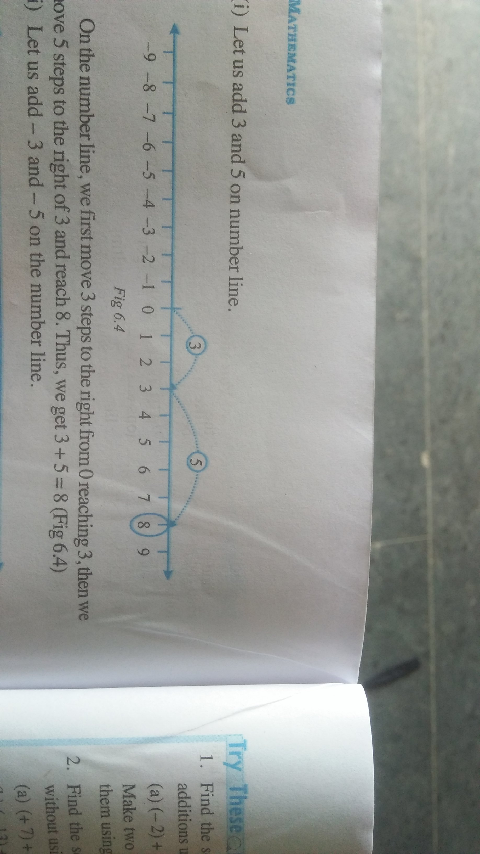
ADDITION SUBTRACTION OF INTEGERS ON A NUMBER LINE:-
EXAMPLE :-
i) Let us add 3 and 5 on number line

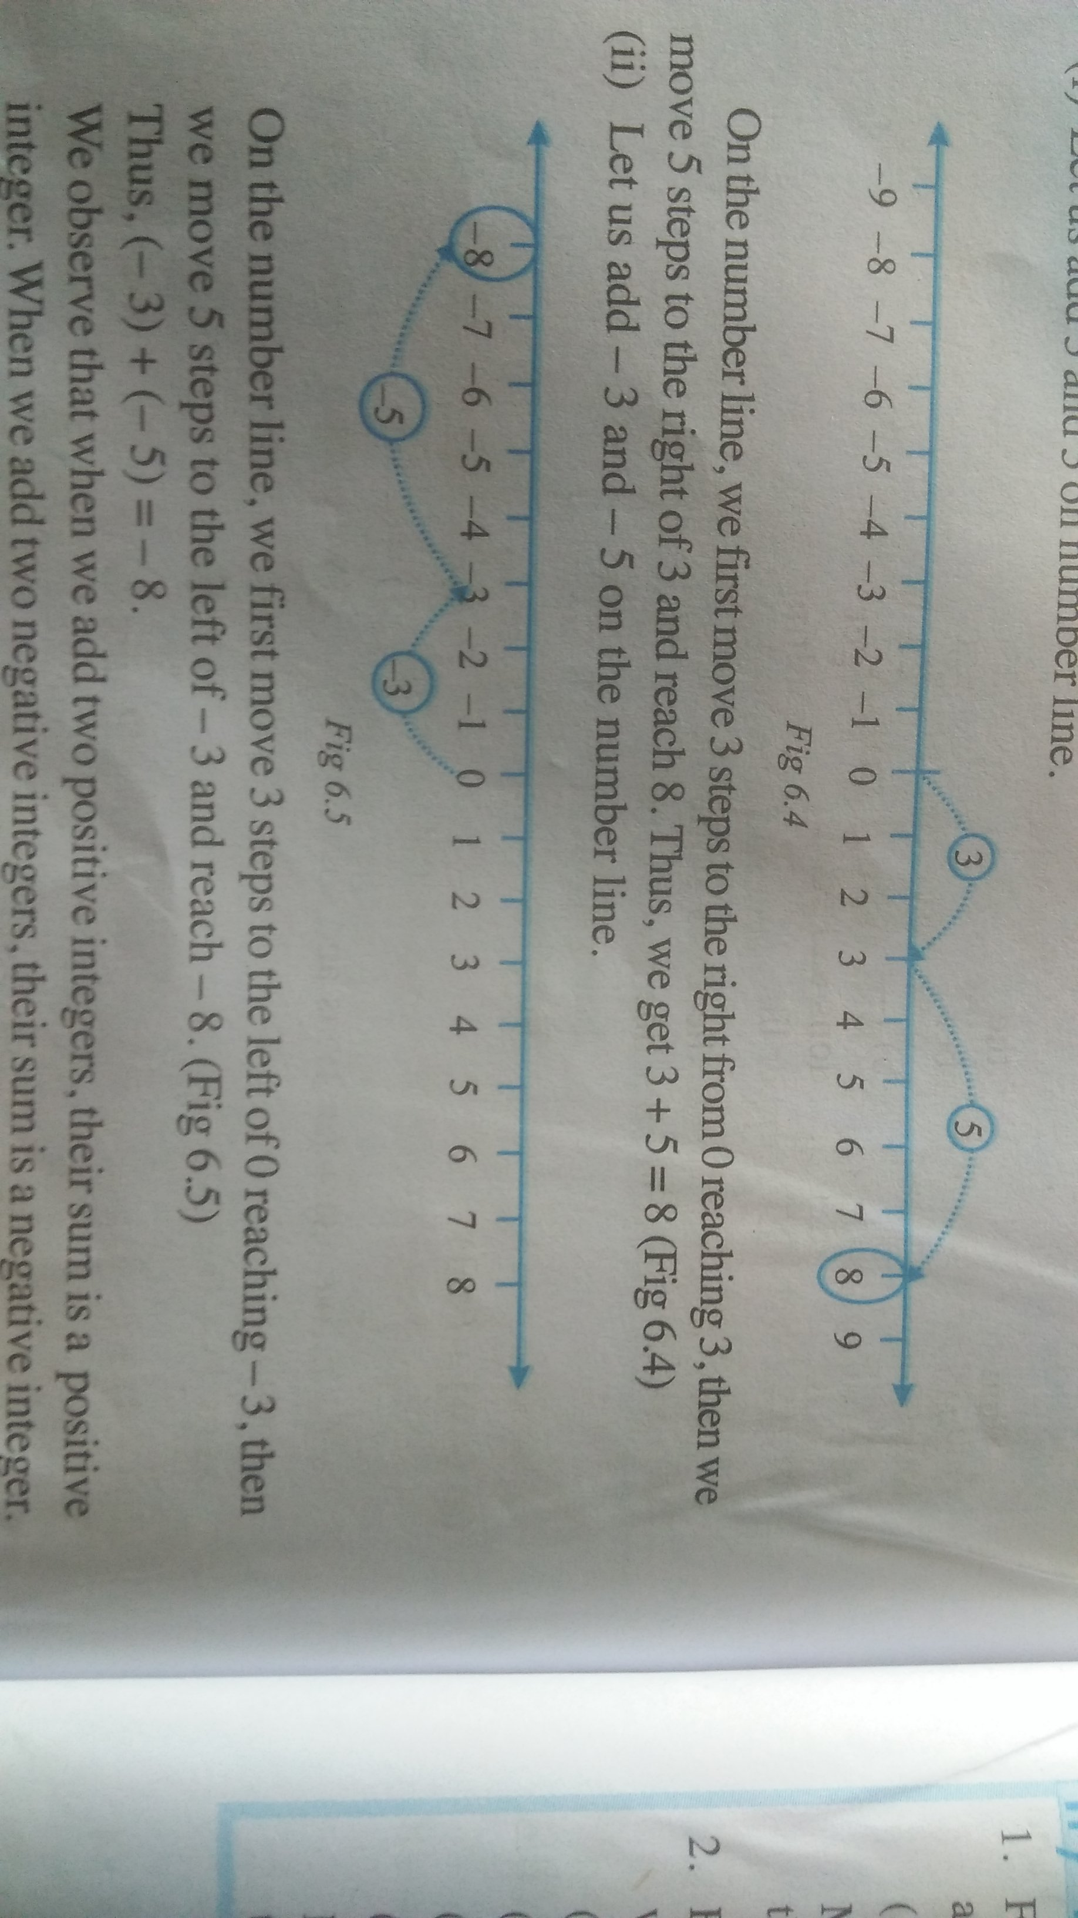
ii) let us add -3 and -5 on the number line

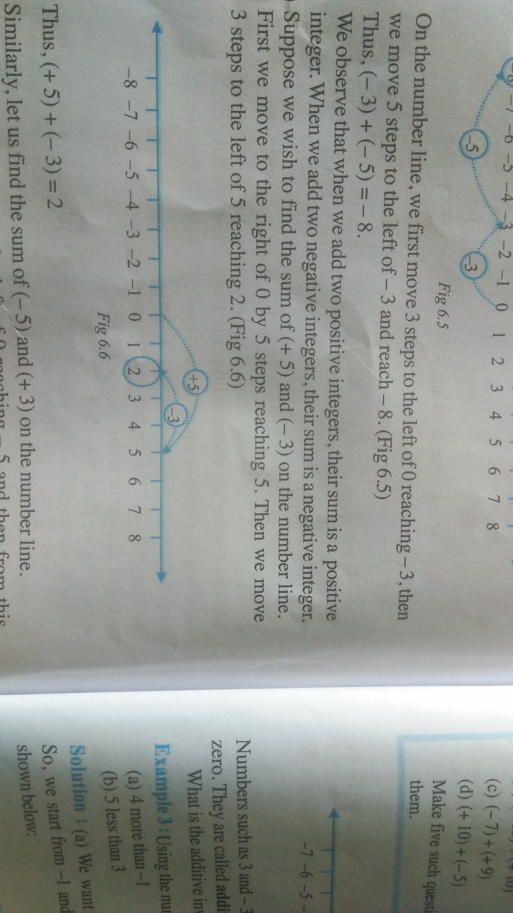
iii ) find the sum of +5 and -3 on the number line
+5 + (-3)
= +5 - 3
= +2

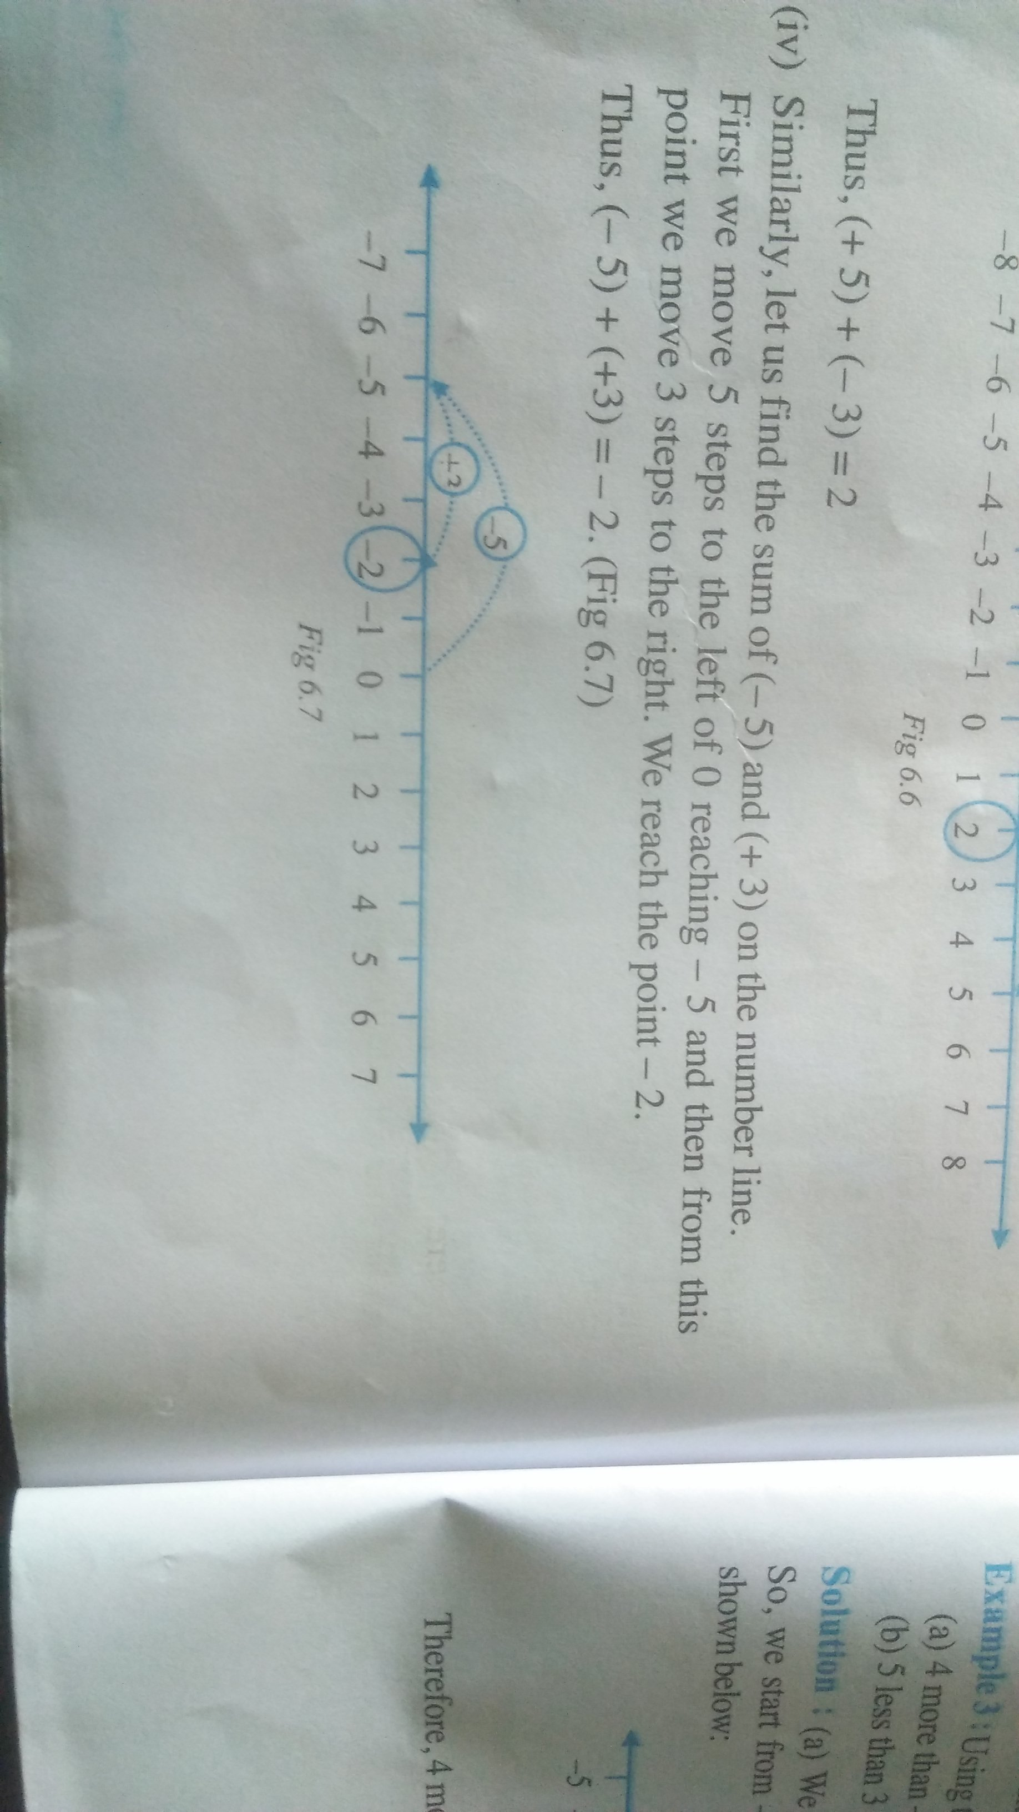
iv ) find the sum of -5 and +3 on the number line
-5 + (+3)
=-5 +3
=-2

I Find the solution of the following using a number line:-
i) 4 + 5 ii) -2-4 iii +6 and -3
iv ) -7 and +3

PROPERTIES OF ADDITION AND SUBTRACTION OF INTEGERS
*) CLOSURE PROPERTY
CLOSURE PROPERTY UNDER ADDITION AND SUBTRACTION:-

The sum of any two integers will always be an integer,i.e .if a and b are any two integers ,a+b will be an integer.....
For example:

7 + 24 = 41 , (-8 ) +6 =2

The difference between any two integers will always be an integer, i.e if a and b are any two integers , a - b will be an integer.

Example:- 19 - 5 = 14 ,-7 - (-4)= -3

*)COMMUTATIVE PROPERTY
COMMUTATIVE PROPERTY UNDER ADDITION
Changing the order of addedds does not change the two integer a and b , we can say
a+b = b+a ___ab
For example, 4+2 =2+4............6
10+2=2+10 ............12

COMMUTATIVE PROPERTY UNDER SUBTRACTION

a-b = b - a
i) 5 - 7 = 7 - 5
-2 = 2
ii 5 +3 = -3-5
8 = -8

We Conclude that subtraction is not commutative for integers.

*)ASSOCIATIVE PROPERTY

ASSOCIATIVE PROPERTY UNDER ADDITION
a+(b+c) = ( a +b)+c
Example i) 5+(7+6)=(5+7)+6
5+13 = 12+6
18 = 18
Associative property hold good on addition of integers

ASSOCIATIVE PROPERTY UNDER SUBTRACTION
a-(b-c)= (a-b)-c
Example a= 5,b=4,c=3
5-(4-3)=(5-4)-3
5-1 = 1-3
4 = -2
Associative property doesnot hold good on subtraction of integers

*)ADDITIVE IDENTITY

Integer 0 is the identity under addition . That is , a+0 = 0+a ------a for every integer a

Example :- 25 + 0 = 25
100 + 0= 100
1000 + 0 = 1000

Excercise
Fill in the blanks -
a ) (-5) + (-8) = (-8)+ (........-5.......)
b) -53 + ........0....= -53
c)17 + .......-17.....=0
d)[ 13 + (-12)] + (.........-7...) = 13 + [(-12)+(-7)]
e)(-4)+[15+(-3)]= [-4+ 15]+.........-3...

