KHIDWAI ENGLISH SCHOOL, SHIMOGA
Subject : Science for class 6th
Electricity and Circuits
4) Complete the drawing shown in Fig 12.14 to indicate where the free ends of the two wires should be joined to make the bulb glow.

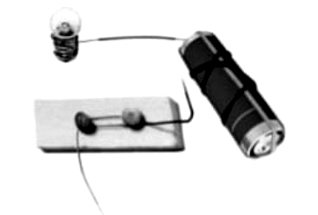
Fig. 12.14
Answer:
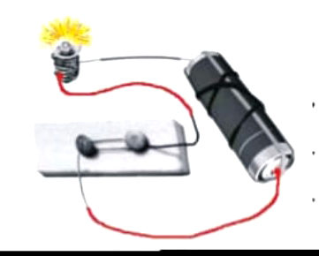

6) Would the bulb glow after completing the circuit shown in Fig. 12.14 if instead of safety pin we use an eraser?
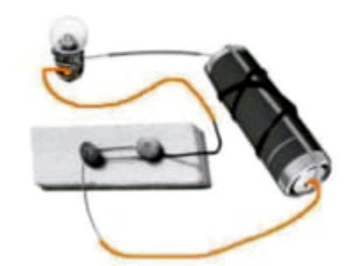
Fig. 12.14
Answer:
Eraser is insulator, so circuit will not complete. As a result the bulb will not glow,
7)Would the bulb glow in the circuit shown in Fig 12.15?
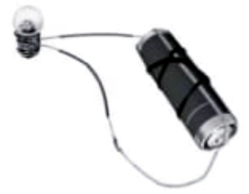
Fig 12.15
Answer : Both the wire are connected to only one terminal of the bulb, so current will not flow through the bulb and it would not glow. We should make a correction as follows:
